README: Grazioso Salvare Rescue Dashboard
Created by: Beau Welchel
Course: CS 340
Project: Project Two : Grazioso Salvare Web Application Dashboard
Project Overview
This project is a dashboard application for Grazioso Salvare. The purpose of the dashboard is to help the client review animal shelter data and identify dogs that may be good candidates for search-and-rescue training. The dashboard connects to the Austin Animal Center Outcomes dataset stored in MongoDB. It lets the user filter the data by rescue type, view matching records in a data table, and see results through a pie chart and geolocation map. The project follows an MVC-style structure. MongoDB is the model because it stores the data. The Dash layout and widgets are the view because they display the information. The callback functions are the controller because they respond to user selections and update the dashboard.
Required Functionality
The finished dashboard includes the Grazioso Salvare logo and my name on the page. The logo is also linked to the SNHU website as required. I used radio buttons so the user can choose between Water Rescue, Mountain or Wilderness Rescue, Disaster or Individual Tracking, and Reset. When one of the rescue options is selected, the dashboard searches MongoDB for dogs that match the project requirements, such as animal type, breed, sex, and age in weeks. The table changes based on the filter selected. I also made the table easier to use by adding options to sort, filter, select rows, select columns, scroll, and move through the records in smaller pages instead of showing everything at once. The pie chart shows the most common breeds in the results, and the map shows the location for the selected animal record. The Reset option clears the filter and returns the dashboard back to the original view.
Tools and Technologies Used
For this project, I used Python, MongoDB, PyMongo, Dash/JupyterDash, Pandas, Plotly Express, Dash DataTable, Dash Leaflet, and base64 encoding. Python was the main language for the project because it let me connect the dashboard to the database and work with the shelter data. MongoDB stored the animal shelter records, and PyMongo helped my Python code pull that information from the database. I used Dash and JupyterDash to build and run the dashboard inside Codio. Pandas helped organize the MongoDB results into a table format that could be displayed on the dashboard. I used Dash DataTable for the animal records, Plotly Express for the pie chart, and Dash Leaflet for the map. Base64 encoding was used so the Grazioso Salvare logo would display correctly on the dashboard.
MongoDB, Dash, and MVC
For this project, MongoDB stores the animal shelter records. I used my CRUD Python module from Project One to connect the dashboard to MongoDB and pull the records needed for each rescue filter. Dash is what creates the dashboard that the user sees, including the filter buttons, table, pie chart, and map. The callback functions are what make the dashboard respond when a filter is selected. This follows the MVC idea because MongoDB handles the data, Dash displays the dashboard, and the callbacks control what changes on the screen.
Steps Taken to Complete the Project
I started by reviewing the project requirements and making sure I understood what the dashboard needed to do. Once I had that figured out, I connected it to the MongoDB database using the CRUD module I created in Project One. From there, I built the dashboard itself, including the logo, rescue filters, data table, pie chart, and map. After the layout was in place, I created the queries for each rescue category and connected everything together with callbacks so the dashboard updates automatically when a user selects a filter. Finally, I tested each option to make sure the table, chart, and map were all showing the correct information.
Testing and Validation
Test Case | What Was Checked | Expected Result | Status
Initial Dashboard Load | Logo, author name,  Filters, table, pie chart and map | Dashboard opens with all required widgets visible | Passed
Water Rescue Filter | Water Rescue radio button, table, pie chart, and map | Widgets update to show Water Rescue candidates | Passed
Mountain/Wilderness Filter | Mountain or Wilderness radio button, table, pie chart, and map | Widgets update to show Mountain/Wilderness candidates | Passed
Disaster/Tracking Filter | Disaster or Individual Tracking radio button, table, pie chart, and map | Widgets update to show Disaster/Tracking candidates | Passed
Reset Filter | Reset radio button and dashboard widgets | Dashboard returns to the original unfiltered view | Passed
Table Tools | Sorting, filtering, pagination, scrolling, and row selection | User can navigate and review records more easily | Passed
MondoDB ID Field | Removal of the _id field before table display | Dashboard avoids ObjectId display errors | Passed
Challenges and Solutions
One challenge was importing the correct CRUD module. The starter code used a different module name, so I updated the import statement to match my file name, CRUD_Python_Module.py. Another challenge was loading the logo because the file name included spaces. I fixed this by matching the image path to the exact file name in the project folder. I also had to handle the MongoDB _id field because Dash DataTable does not display ObjectId values cleanly. I fixed this by removing the _id column before loading data into the table. Another challenge was keeping the map from failing if no row was selected, so I added logic to default to the first row when needed.
How to Reproduce the Project
To reproduce this project, place ProjectTwoDashboard.ipynb, CRUD_Python_Module.py, and Grazioso Salvare Logo.png in the same Codio project folder. Open ProjectTwoDashboard.ipynb in Jupyter. Confirm that the import statement says from CRUD_Python_Module import AnimalShelter. Confirm that the MongoDB username and password match the aacuser account. Run the dashboard cell. Once the dashboard loads, test each radio button filter and confirm that the table, pie chart, and map update.
Resources Used
Python: https://www.python.org/
MongoDB: https://www.mongodb.com/
PyMongo: https://pymongo.readthedocs.io/
Dash: https://dash.plotly.com/
Dash DataTable: https://dash.plotly.com/datatable
Plotly Express: https://plotly.com/python/plotly-express/
Dash Leaflet: https://dash-leaflet.herokuapp.com/
Pandas: https://pandas.pydata.org/
Codio: https://www.codio.com/
SNHU course materials and Grazioso Salvare dashboard specifications document were also used.
Development Note
I used AI assistance as a support tool for organizing my README, troubleshooting errors, and reviewing my dashboard documentation. I completed the project in Codio, tested the dashboard functionality, verified the filters, and finalized the submitted files.

Figure 1: Starting Dashboard/ Reset View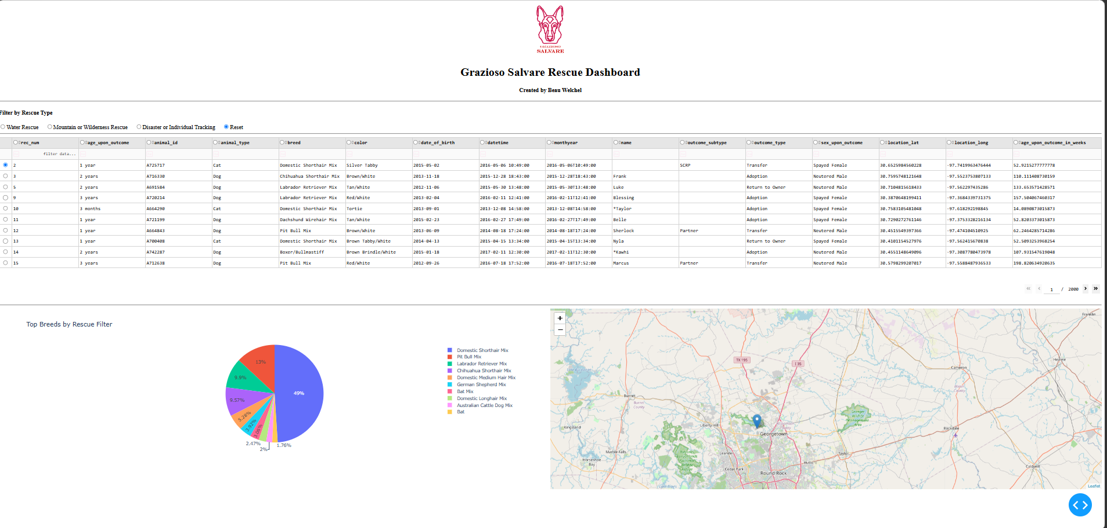

Figure 2: Water Rescue Filter
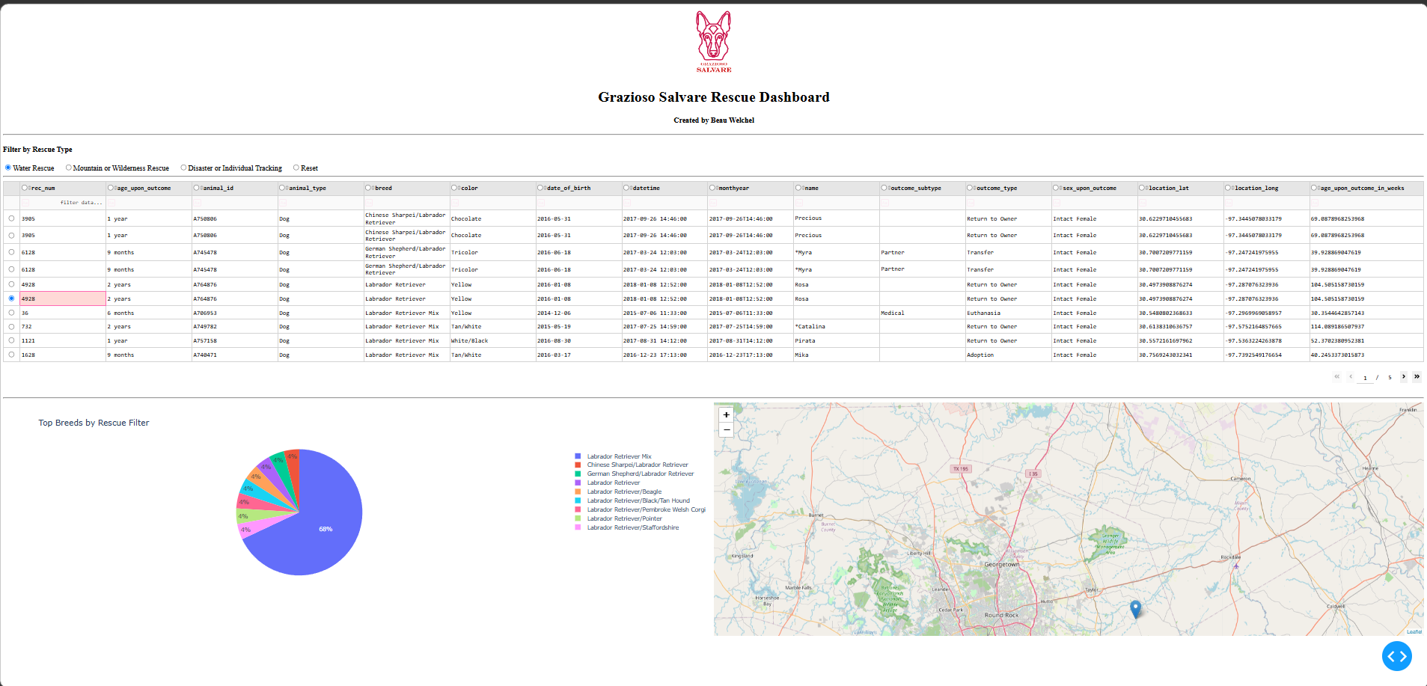

Figure 3: Mountain or Wilderness Rescue Filter
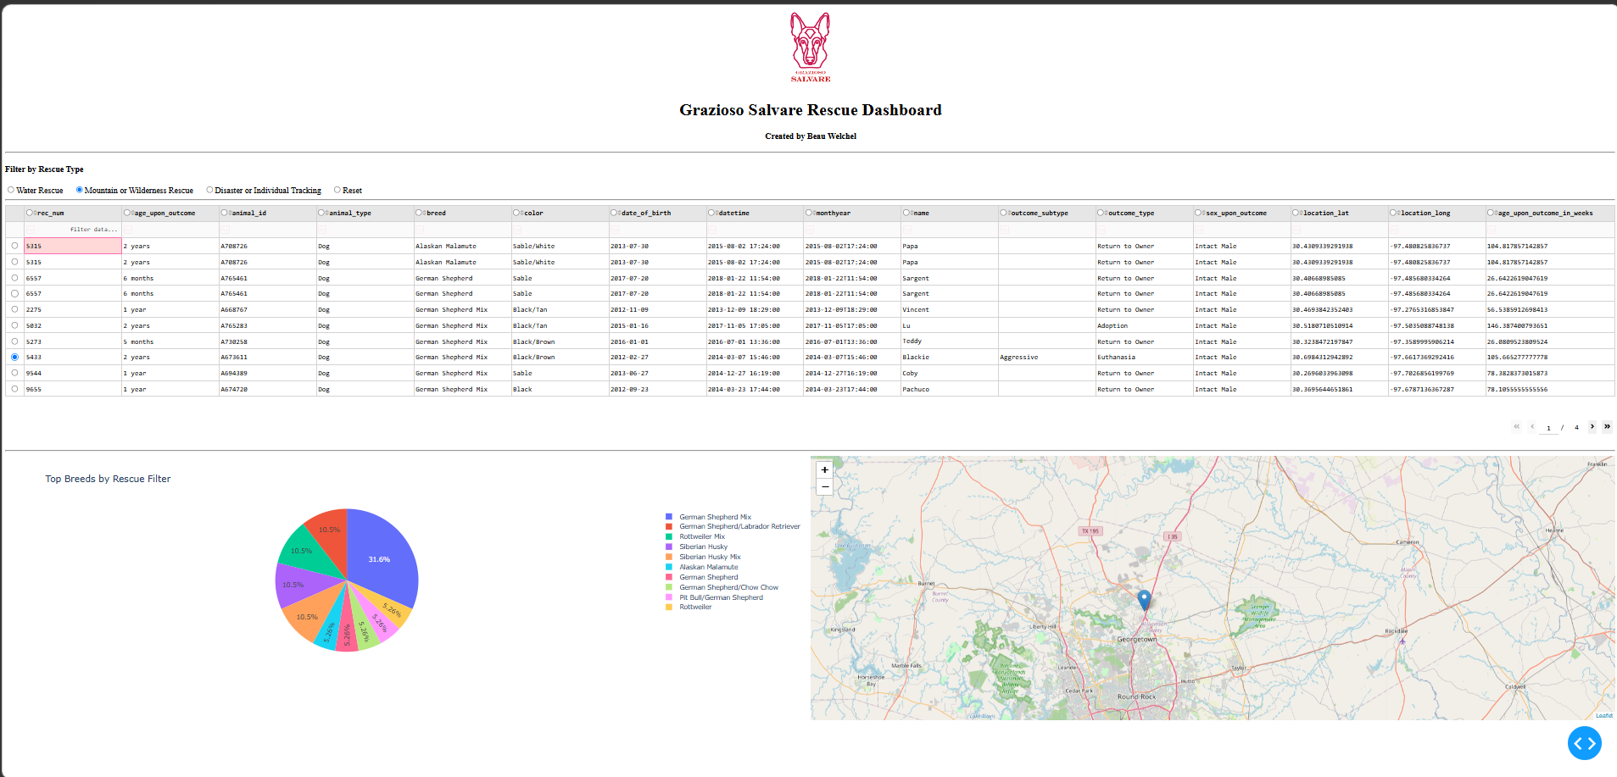

Figure 4: Disaster or Individual Tracking Filter
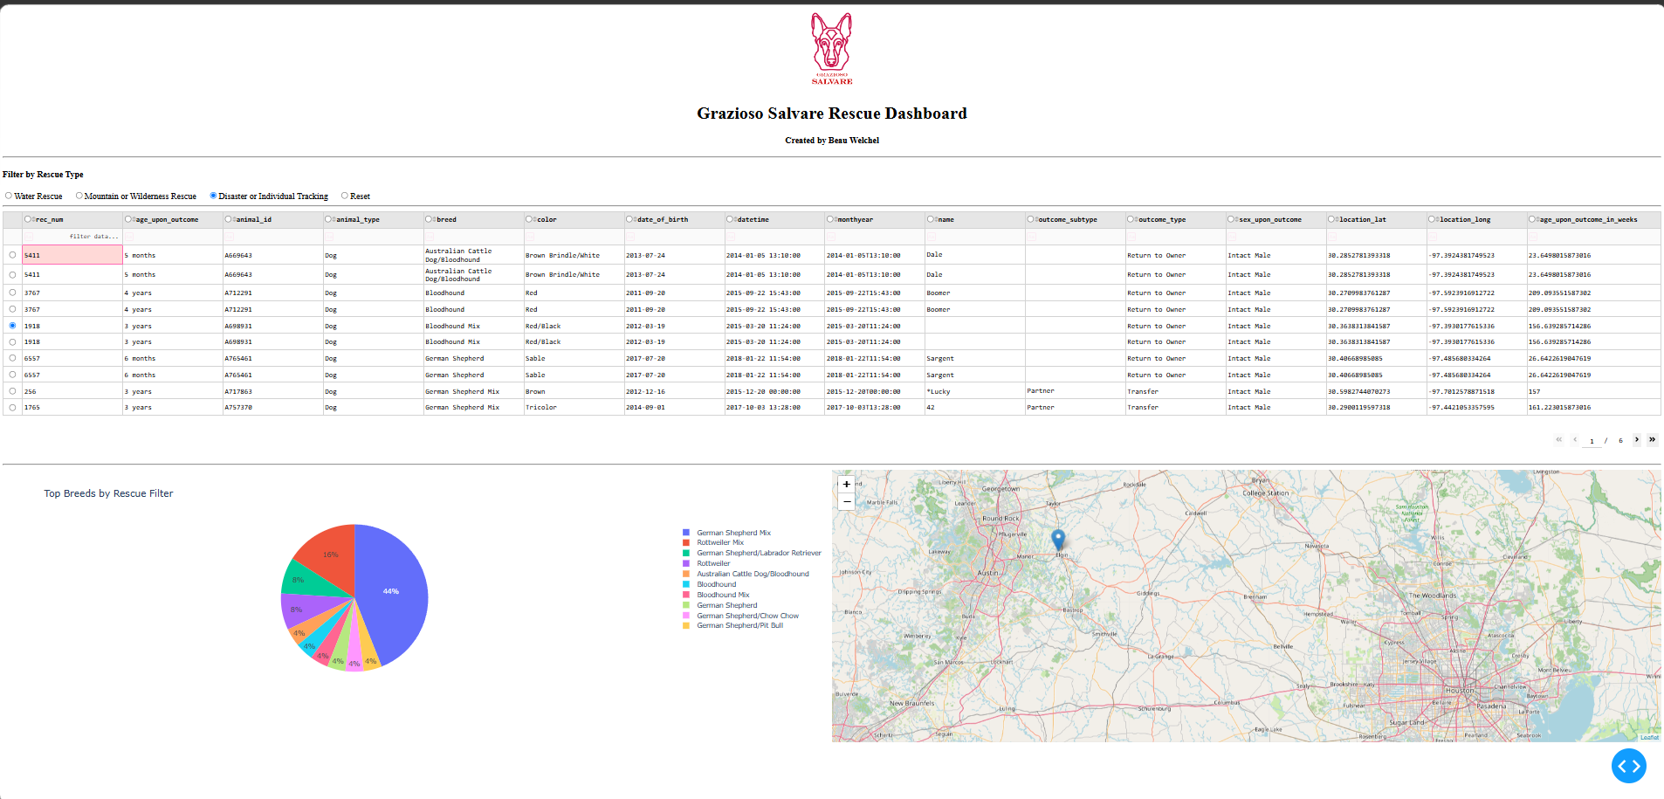

Figure 5: Reset View
